Python bootcmp day 1

Band Name Generator



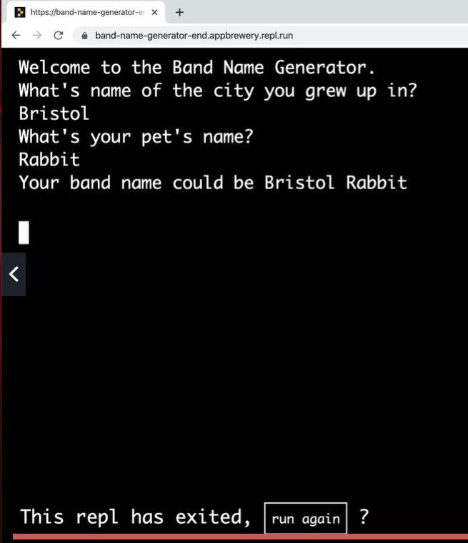

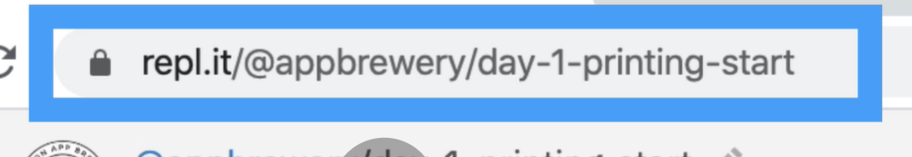

<https://repl.it/@appbrewery/day-1-printing-start#main.py>

coloradoz99 gmail and midnight

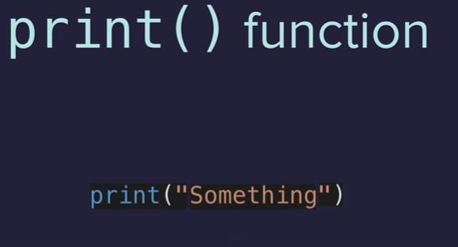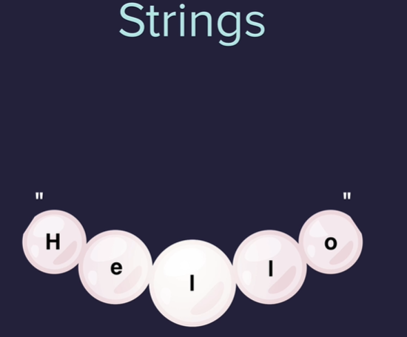

Single print method to print 3 lines

Use \n

The run shortcut is CNTL Enter

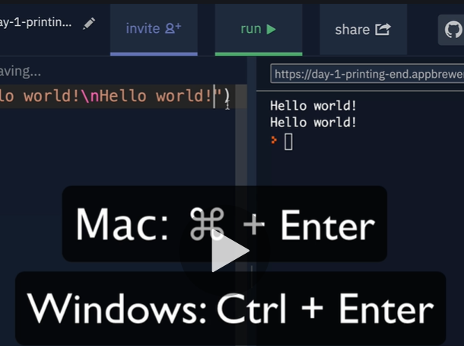

To concatenate

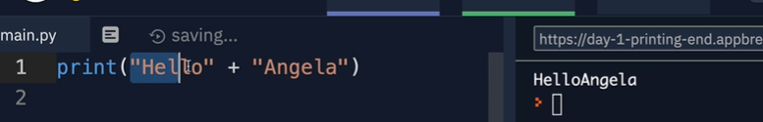

Spaces are important in python

Python input function

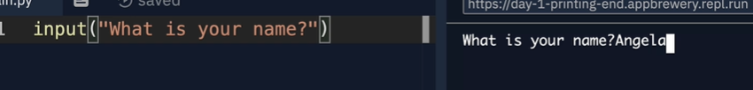

Variable naming

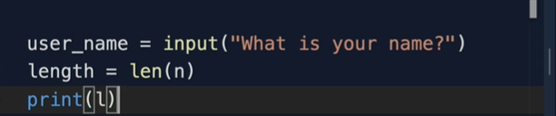

Restart here at #14

<https://www.udemy.com/course/100-days-of-code/learn/lecture/17837506#questions>

Interview question   
"Write a program that switches the values stored in the variables a and b."